RuleBook

# General:

This is a multiplayer half RTS, half Turn based strategy game that has each player choose a specific faction, build cities, units buildings and special units to fight each other, conduct diplomacy and win the battle for Aven!

# How to Win

Win Condition, if after build phase one player has:

* 70 population

That player instantly wins the game and players will be seeded by total population.

Edge case: If two players reach the winning population at the same time, the player with higher objectives completed will win. If players have the same objectives completed the player with higher gold will win. If players have equal gold, they will tie (unlikely case).

Or become the first player to complete five objectives

# Objectives:

The player who completes five objectives first will win the game.

Completing an objective gives + 3 population

Defeating a calamity qualifies as claiming it’s tile

Killing an enemy unit means, the enemy unit dies during a combat phase where you have assigned damage to that enemy. IE in multi player combat, if you deal 1 damage to the enemy, and another player deals 6 and the enemy commander dies, you both get credit.

Defeat 10 enemy units (Commander units and Calamities do not count)

Defeat a Calamity

Reach 200 gold

Defeat an enemy Commander

Field 15 units

Build every building

Have two Metropolises

Have two citadels

Have four cities

Have four castles

Explore three ruins

Edge case: As completing an objective can occur during different phases of your turn, the win will trigger as soon as this condition is fulfilled. Eg: Killing your tenth enemy unit will immedietly win you the game.

Tie breaker: Population, then gold, if all is equal, then tie.

# Map:

Hexagonal tiles with 6 different types

Plains → no special effect

Caves → Provides +1 Crystal

Farmland → Provides +2 Food

Forest → +1 Wood

Mountain → +1 Metal

Water → impassable

The board will be 10x10 Hexagonal tiles, organized in square format

# Settlements:

Settlements are bases of humans that can store buildings and provide zones of control. There are two categories: civilian and military settlements split into three tiers. Settlements must be placed at least 2 hex tiles away from any other settlement. If during the build phase two players build a settlement that would result in the rule being violated, both are cancelled, thus forcing them to come to a compromise or fight it out.

Settlements cannot be placed on water tiles

Each player will start with one city.

Military:

Tier 1: Fort

Tier 2: Castle

Tier 3: Citadel

Civilian

Tier 1: Town

Tier 2: City

Tier 3: Metropolis

## Zone of Control

Zone of Control is the tiles that a player can choose from to claim a resource and build a building. Forts have no zone of control, Castles, Citadel, Towns and Cities have 1 zone of control and Metropolises have two.

Two players can never have overlapping zone of control. It will always defer to the player who placed their settlement first.

## Develop Tile

At tier 2, the settlement will have the option to develop tile. This will increase the amount of resources that tile provides. Developing tile at tier 2 costs 6 gold, 2 wood and 2 metal. It will provide 2x the base yield resource of that tile.

At tier 3, the settlement will have the option to develop tile. This will increase the amount of resources that tile provides. Developing tile at tier 2 costs 10 gold, 3 wood and 3 metal. It will provide 4x the resource of that tile.

Edge case: two players cannot develop the same tile as they will never have overlapping zone of control

# Buildings:

All nations will follow a standard framework with certain exceptions that can be weeded out.

Cost of buildings is defined in the Buildings Stats file

**Tier 1:**

Barracks - Allows tier 1 units

Farm - provides food and some gold

Mine - provides metal and wood

**Tier 2:**

Metal refinery - gives metal

Crystal refinery - gives crystal

Armory - provides tier 2 units

Balista Tower - provides one extra attack for the city

Bank - provides a significant amount of gold

**Tier 3:**

Commander’s Lodging - allows recruitment of commander for faction

Special Unit building - allows recruitment of special unit for faction

Factory - provides everything except crystal

Walls - provides 2 extra hitpoints

# Resources:

## Population

Population is accumulated through building your own settlements, taking settlements from others, defeating calamities and completing objectives.

Population can be spent to create units. If a player spends population on units, that population is lost.

Edge case: When a player has spent population and reaches negative population when their settlement is taken, they will be unable to produce new units until they reach positive population.

Edge case: If you do not have enough Food, Gold, Metal, Wood or Crystal to build something you cannot build it.

Gold

Metal

Food

Wood

Crystal

# Terrain:

Plains → no special effect

Caves → Provides +1 Crystal

Farmland → Provides +2 Food

Forest → +1 Wood

Mountain → +1 Metal, only tier 2 and above can travel here

Water → impassable, provides 1 food

# Units:

Each unit/unless specified otherwise, will only have one movement per turn.

Units can spawn on any tile that has the appropriate building.

There is no limit to how many units can stack on a tile, in terms of UI, The highest ranking (designated by Unit ID) Will be displayed first, with a number below to show how many total units in that square.

Tier 1:

Soldier

Archer

Tier 2:

Knight

Mage

Catapult

Tier 3:

Commander Unit

Special Unit

# Claiming a tile

When a player is the first to enter a tile, and no other player is there, a tile is claimed. If two players truce and enter a tile, the tile has not been claimed and calamities/settlements etc, are not claimed.

# Ancient Ruins

Are placed at the beginning of the game

When a player claims this tile, they receive benefits

List of benefits:

+4 population

+6 population

+2 population  
+1 soldier

+1 knight

+1 archer

+1 catapult

+10 gold

+15 gold

+20 gold

# Calamities

Calamities are bosses that players can defeat for rewards.  
  
Four players → three total: The Revolutionary, Galen The Swordsman, Atriarch

Five players → four total: The Revolutionary, Galen The Swordsman, Atriarch, Vanessa The Seer

Six players → five total: All calamities

Calamites will spawn at least 3 tiles away from any player beginning settlement. They Do not respawn once killed. They spawn on setup.

Calamities will randomly assign their hits to X number of players attacking it. For example, two players attack Galen the swordsman, he rolls 3 for 3, and lands 3 hits. Those hits will be randomly assigned to the players attacking him.

Killing a calamity during your

## The Revolutionary

Dissatisfied with the state of Aven, the Revolutionary seeks to establish his own kingdom.

The revolutionary spawns with a soldier protecting him on each surrounding tile. The first player to claim the tile the revolutionary is on will receive:

+10 Population, +40 gold and have each settlement give +2 population.

## Galen The Swordsman

Galen is a renowned hero in Aven, known for never losing in single combat. He is as powerful as a commander tier unit. He has an open challenge to any who defeats him. The first player to claim the tile Galen is on will receive:

+10 Gold, 5 Metal and 5 Crystal and Galen will join their cause.

## Atriarch

Atriarch is a huge reptilian creature that has terrorized Aven.

The first player to claim the tile Galen is on will receive:

+1 Hipoint to every unit you control.

## Vanessa the Seer

Vanessa was once a renowned mage before she fell from grace. Now she sits in her swamp of death, cursing any who dare cross her path.

All units within one tile of Vanessa will be poisoned and will be attacked by a 1 for 1 d6.

The first player to claim the tile Vanessa is on will receive:

+10 Crystal, +20 gold, every mage you field will have their ranged attack increase by +1. Eg 1 for 3 becomes 1 for 4.

## Jeremiah The Hobgoblin Trickster

Jaremiah is the most notorious criminal to ever walk Aven. He is an immortal, omnipotent god who transcends all dimensional and temporal limitations. Or so he says. At the very least, it is almost impossible to hit him. The only way to defeat him is to have one of your unit types in four of the surrounding tiles he is in. You may try to attack him, but he will take no damage and roll a 1 for 6 on you.

When turn ends with four of one player’s units around Jeremiah, he will despawn and leave his tile open.

The first player to claim the tile Jeremiah is on will receive:

+150 Gold, + 20 population, +20 food

## 

# Turns:

Turns occur simultaneously

Turn will follow three steps and all steps happen simultaneously for each player.

Build Phase, Combat Phase, Diplomacy phase

The game can instantly endon at any point of the turn, if the win-conditions are met.

## 1st Turn

Each player will start with 1 city, 1 soldier and 1 archer that can move. No tiles will be developed, they will be able to choose which resources to select.

## Build Phase:

### Phase 1, Settlements and Buildings:

There must be at least two or more hexes that block

At the beginning of each turn, collect resources based on total income.

Then build cities and buildings within the game rules, and NAME them. Auto generated names will be used as default.

Edge case → if two or more players build a settlement that would result in settlements being closer than the rules allow, both will not place and players will be refunded the cost

### Phase 2, Resource Selection:

If players placed or upgraded a new settlement, they may now choose which resource they acquire by selecting that hex. Once a box is selected, it cannot be unselected.

## Combat Phase:

Notation:

A for B means:  
  
Roll A number of D6 and if B or lower is rolled, a hit is registered.

1 hit removes 1 hitpoint.

Total hits exceeds HP of enemy force, the enemy force is instantly destroyed, however the attacker must still take damage. Mutual destruction of all forces attacking each other is possible if both forces attack each other and deal lethal damage.

## 

### Phase 1: Ranged Attack

All ranged units, including settlements, will fire.

If there are no valid targets on the board, this phase is skipped.

Players will click ready, and dice will be rolled and hits will be registered.

### Phase 2: Movement

Players move units and click ready.

If units come into contact, they roll their attack or defensive rolls. If two units move into the same square, they both roll attack.

If three or more units from different squares roll into the same tile, each player will choose which player to assign their attack hits too, and then will assign their defensive hits. EG: Player 1,2,3 walk into a tile. Player 1,2,3 all roll offensive attack, then choose how many hits to assign to the other players. Players 1,2,3 then assign their defensive hits based on how may offensive hits they received.

If two or more of your units are in a square and the total number of Hits is less than the number of Total HP of the units in the square, each player will assign which units received damage.

EG: A commander, knight and soldier of team one attack a knight and two soldiers of team 2. Team 1 swings for 2 and Team 2 swings for 2. Each player will then assign which units tank the hits. Ideally Team 1 would assign hits to their commander so as to not lose their knight and soldier and Team 2 would assign hits to their soldiers, to avoid losing their knight.

If players do not want to fight, there will be a button which displays a white flag which will allow multiple players to enter that tile without fighting each other. Both players must click the button for the deal to go through. If two players want to truce and fight one, depending on how many people are in the tile, the white flag button will, when pressed, expand to show each of the players in that tile, where you will then click who you want to truce with.

## Diplomacy Phase:

In the diplomacy phase nations can ratify deals made to others in the public eye in a logged domain available to all, or make deals in private. The diplomacy phase has a maximum of two minutes.

After round 8 this becomes 1 minute.

Binding deals:

Gift or trade → However many resource, population cannot be traded

Unbinding deals:

Truce

Alliance -

Non-aggression pact, can be total or for a specific city.

### Single Player:

In single player, FOR NOW we will build an AI that just acts in a certain way aggressive, defensive or balanced.

## 

# Factions:

## The Kingdom of Avenguard

A people led by the great King Joseph Avenguard, whose lineage can be traced back to the first settlers who came to Aven. The Kingdom promotes traits such as honor, courage and faith, fielding great knights and having powerful castles to protect them. The Kingdom’s Commander is Prince Rufus Avenguard, a warrior who fights at the front and boosts his soldiers’ abilities. The Kingdom’s special units are the “Avenguard Paladin”, who possess powerful defense and offensive capabilities as well as being able to tank unholy amounts of damage by invoking a holy prayer. The Cities and Metropoleses of Aven receive a bonus to their population and defense.

Commander: Prince Rufus Avenguard

Special unit: Avenguard Paladin

Bonus: The Cities and Metropoleses of Aven receive a bonus to their population and defense.

Colors: Blue, White, Silver

Vibes: Typical fantasy kingdom, The vanilla faction

Physical traits: medieval knight, chainmail, armour, flowy fabric

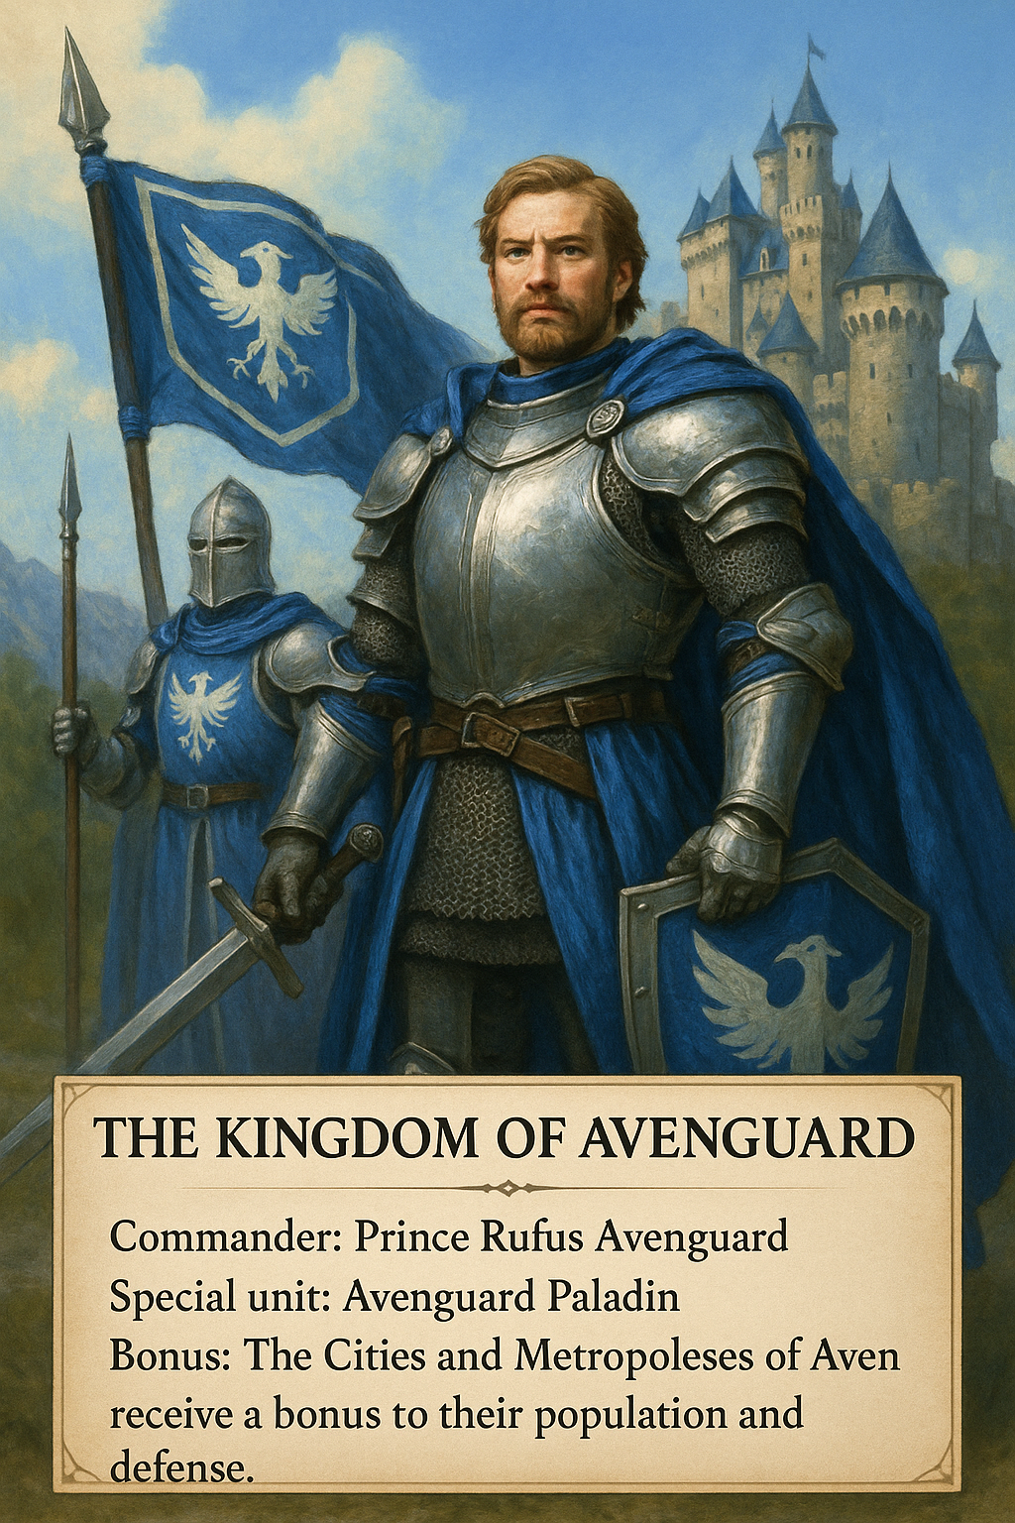

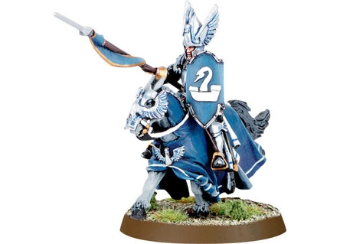

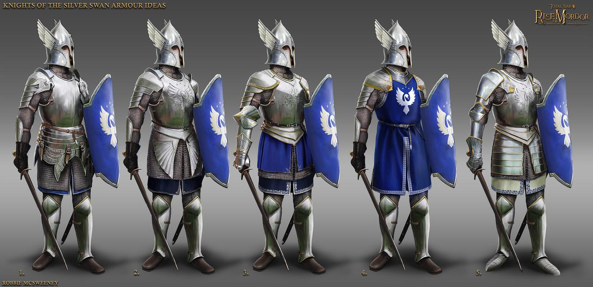

## Müselheim

Müselheim is home to the dwarves who inhabit the **mountains and caverns** of Aven. They are a people who take no pleasure in doing business with others and prefer to keep to themselves. They are **short, grumpy**, but have a deep love for all things **gold**. Müselheim’s Commander is the great dragon “Belarin”, he has immense destructive ability, but is only able to move once every two turns, due to his old age. Müselheim’s special units are the “Dungeon Keepers” who have unbreakable defenses and are able to use their gunpowder to reduce the effectiveness of defensive structures. Müselheim’s mines produce twice as much gold as normal.

Commander: Belarin

Special unit: Dungeon Keepers

Bonus: Bonus to gold produced on settlements and buildings, Stronger defense on settlements, less population in settlements

Colors: Grey, Black, Gold

Vibes: Mining, coal, dusty, stumpy, defense based

Physical: Squarey, structured, intricate patterns, big shield, heavy armor

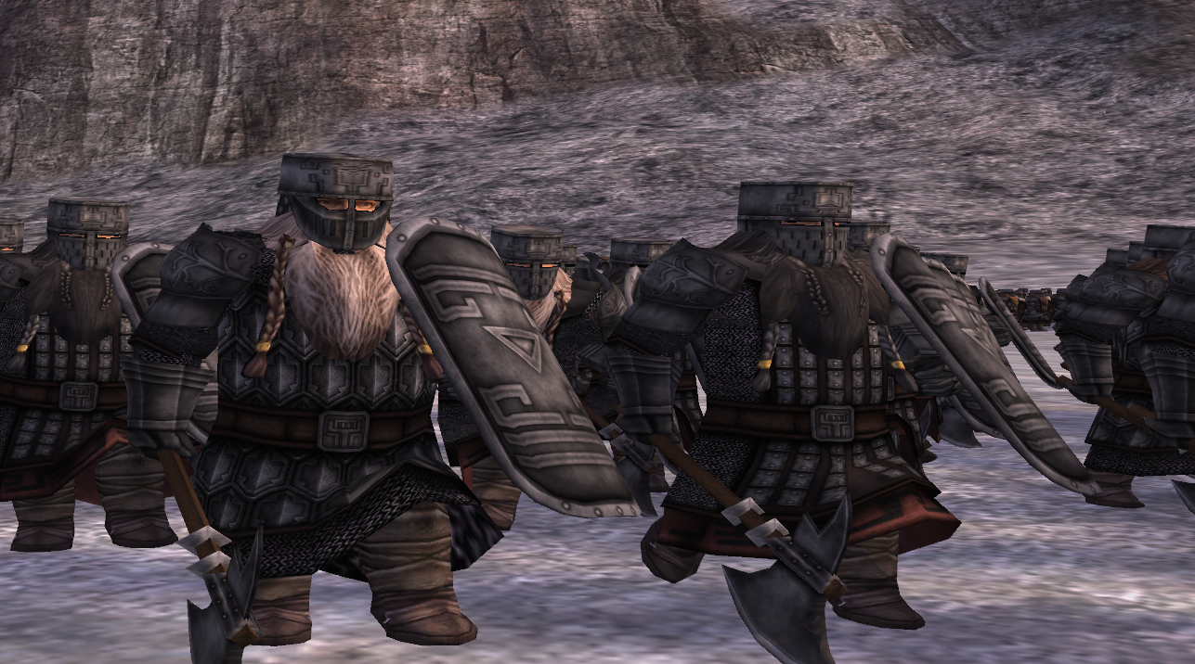

## The Woodland Haven

The Woodland Haven is home to the miscellaneous creatures of the **forest**. The Haven are a progressive and inclusive faction home to many different species. As such, although they are numerous, their defense and production lack behind due to their focus on **magic and exploration**. Their commander is “Alindael”, the guardian spirit of the Haven, able to heal her allies and move anywhere controlled by forest tiles, if she is in a forest tile. Although weak in combat, her mobility and utility make her an immensely difficult challenge. She also buffs her nearby allies.

The Haven’s special unit is the Elven Longbows. They have extra range, attack damage and mobility.

The Woodland Haven is not capable of producing Forts, Castles or Citadels. This is made up for by the fact that their Towns cities and Metropolis’ give +1 food and population.

Commander: Alindeal

Special Unit: Elven Longbows

Bonus: No fort line buildings, bonus to food and population.

Colors: Light Green, Dark Green, Brown, light yellow?

Vibes: Forest, varying sizes of friendly Animals (zoo), peaceful, clean, neat

Physical Traits: Ballet/Yoga, pointy but not sharp, curves/swoops

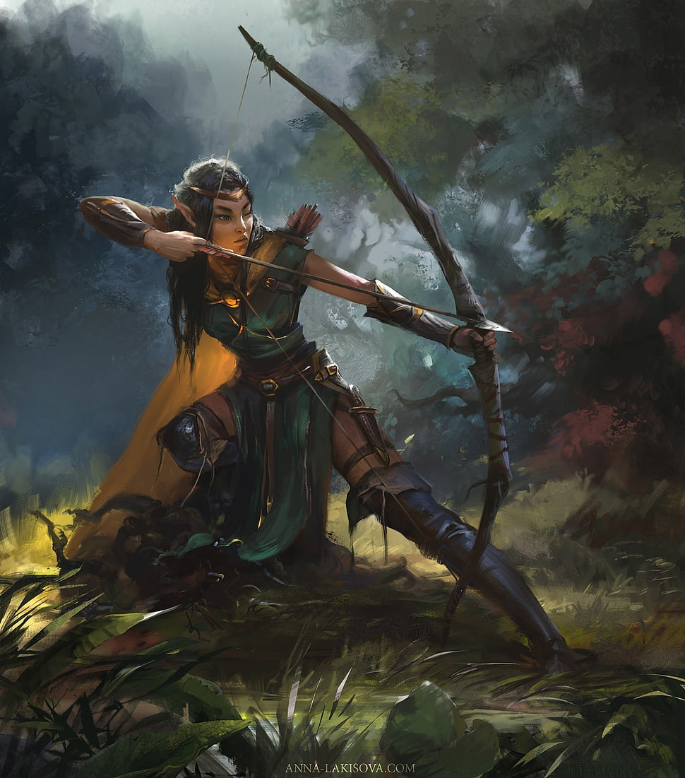

## Sons of Rexathimgrod (Rex)

The Sons of Rexathimgrod are born from the rage of the battlefield. They do not understand how to properly interact with other species and spend most of their time fighting each other to the death. Their commander is Rexathimgrod, an immortal warrior who dies countless times in battle, only to be resurrected due to his own rage and become stronger. Each time Rexathimgrod resurrects he increases his hp and attack damage. The special units of the sons of Rexathimgrod are the Howlers. These are **half human monsters** who express the purest forms of **rage**. They heal based off of damage done to others. The Sons’ settlements provide 1 less population, but their units are less expensive and have slightly more hp.

Commander: Rexathimgrod

Special Unit: Howlers

Bonus: 1 less population from settlements and buildings, less expensive units and more damage on units.

Colors: Red, Dark Silver Orange

Vibes: Fire, Explosive/Reckless, Primitive

Physical Traits: Messy, Strong/Big/Body builder, Spikes,

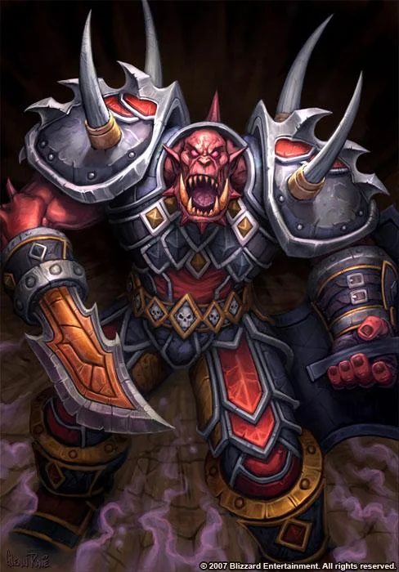

## The Amethyst Enclave

The Amethyst Enclave is a nation led by the greatest magicians in the land. Their skill and knowledge is surpassed by none. They possess a brilliant academy of mages that passes down their knowledge through the generations. The Enclave’s commander is Selina Sorek, the greatest living mage. She wreaks havoc with area of effect attacks, transfiguration spells that last for 2 turns. The only downside is her weakness in combat. The Enclave’s special unit is the Warlock. A Warlock is a fully-fledged mage, capable of locking units in place and spreading damage to other units with their electric magic.

The Enclave’s crystal refineries produce double the yield and their mages have an attack bonus.

Commander: Selina Sorek

Special Unit: Warlock

Bonus: Crystal refineries produce double the yield, attack bonus to mages.

Colors: Purple, light purple, Azure blue

## 

## The Farheed Commonwealth

The Commonwealth is a nation of traders. They possess no great skill at arms and no magic, unlike the other factions. The Commonwealth relies on the strength of its economy and its trade deals. They are also specialists in economic manipulation, bribery, and intel. Their Commander is Chancellor Vel Witking, a self made man who rose from the bottom of society to become the leader of the Commonwealth. Vel uses a suit to augment his abilities and has moderate offensive and defensive capabilities. His primary skills are that when he is alive, every production building within 3 tiles of him receives a +1 bonus(does not affect cities and settlements). He also has the ability to target special enemy units and bribe them/coerce them into switching sides (the ability must land and does not affect commander units or calamities).

The Commonwealth’s special unit is the “Tax Collector”. The Tax collector will generate +1 gold per turn and boost gold production in nearby cities and settlements within a one block radius. Tax collectors can bribe adjacent, tier 1 and 2 units, at a price of 4 gold per cast. Tax collectors have average combat stats.

The commonwealth benefits from cheaper buildings and has

Commander: Vel Witking

Special Unit: Tax Collector

Bonus: cheaper buildings, espionage choose one person, look at their resources and steal one. Only one resource, per person, per round.

Colors: Yellow, Maroon, Green

Vibes: Caravans, spies, merchants, etc

## 

# 